UpTrend: An Intelligent Educational and Simulated Trading Platform for Improving Decision-Making in Beginner Retail Traders
Abstract
Millions of new investors have entered the equities and derivative markets thanks to the exponential rise in retail participation in financial markets, which has been made possible by easily available internet trading platforms and social media impact. However, the vast majority of these novices start trading with poor financial literacy, no knowledge of risk management concepts, and a lack of awareness of behavioral biases, which frequently leads to rash decisions and big financial losses. While stand-alone training resources continue to be dispersed and lack integration with real-world application, traditional trading platforms primarily concentrate on order execution, sophisticated charting, and real-time analytics.
The concept, development, and implementation of UpTrend, a full online application built on the MERN stack that tackles these issues by establishing a single educational-to-simulation pipeline, are presented in this paper. A structured Beginner Trading Academy with quiz-based tests, interactive candlestick charts for real-time market data visualization, dynamic portfolio management, a realistic paper trading simulator driven by the Yahoo Finance API, comprehensive transaction history, and performance analytics are all seamlessly integrated by UpTrend. The platform allows novices to gradually increase their knowledge, apply ideas in a risk-free setting, evaluate their performance, and acquire disciplined trading habits by fusing concepts from behavioral finance, educational technology, and simulation-based learning.
The finished solution shows how an integrated digital platform can successfully close the crucial gap between trading readiness and accessibility. The UpTrend platform's theoretical underpinnings, system design, technical implementation specifics, main modules, observable results, and broad future research prospects are all covered in this document.
Keywords: Financial Literacy, Portfolio Management, Paper Trading Simulator, Behavioral Finance, MERN Stack, Retail Trading Education, Educational Technology, and Decision-Making
I. Introduction
Financial markets have become very democratic during the past ten years. Entry hurdles for retail investors have been decreased with the introduction of user-friendly mobile applications, zero-commission brokerage services, and extensive financial content on social media platforms. Millions of new demat accounts have been opened by young people, students, and novice investors in numerous emerging economies, including India. The fact that the majority of inexperienced traders lack the fundamental understanding and psychological readiness necessary for long-term success in unpredictable markets has been revealed, despite the fact that this increased participation represents greater financial inclusion.
Beginner retail traders frequently experience cognitive biases such overconfidence, loss aversion, herd mentality, and recency bias, according to empirical data from behavioral finance. These psychological elements frequently result in overtrading, poor risk management, and early capital depletion when paired with insufficient formal instruction. Traditional trading systems mainly provide execution tools and assume users already have the requisite expertise. However, current teaching materials, such as blogs, courses, and videos, are often theoretical, disorganized, and unrelated to practical application.
The UpTrend platform was conceived, planned, and completely deployed as an intelligent, beginner-centric teaching and simulated trading ecosystem to address this complex issue. UpTrend is a full-stack online application that offers a comprehensive learning-to-practice experience in a single, cohesive environment. Beginning with organized academy courses, users apply their knowledge in a realistic paper trading simulator utilizing real-time market data, follow the performance of their portfolio, evaluate their choices using extensive transaction history and analytics, and reinforce their learning through interactive quizzes. This document details the UpTrend project's whole development process, technical implementation, and results.
II. Problem Statement
Despite the proliferation of trading applications, beginner retail traders continue to face high failure rates in their initial years. The primary reasons include fragmented financial education, absence of risk-free practical environments, and lack of behavioural guidance during decision-making. Most platforms thrust users directly into live markets without adequate preparation, resulting in emotionally charged decisions that contradict sound financial principles.
A steep learning curve is also produced by the gap between theoretical knowledge and real-world application. It is difficult for novices to convert conceptual understanding of order types, risk management, or market dynamics into consistent trading behavior. An integrated system that offers realistic simulation, instant feedback, performance tracking, behavioral reinforcement, and user education on a single, coherent platform is desperately needed.
UpTrend was created expressly to address this issue by providing a methodical, systematic approach that thoroughly educates novices before they contemplate real-market exposure.
III. Objectives of the Project
The primary objectives of the completed UpTrend platform are:
- To deliver structured, progressive financial education through a modular academy with assessment mechanisms.
- To implement a realistic paper trading simulator that utilizes live market data for authentic practice.
- To develop a robust portfolio management system with dynamic valuation and performance analytics.
- To enable users to practice trading strategies without financial risk while maintaining simulation integrity.
- To provide comprehensive transaction logging and history for reflective learning and performance review.
- To create a responsive, intuitive, and engaging user interface suitable for beginners.
- To build a scalable MERN-stack architecture that supports future AI enhancements and extensions.
IV. Literature Review
The conventional presumption of rational investor behavior in the efficient market hypothesis is being challenged by the vital field of behavioral finance. People do not assess profits and losses symmetrically, as revealed by Daniel Kahneman and Amos Tversky's seminal work on Prospect Theory (1979). Rather, loss aversion is the tendency for people to be more sensitive to losses than to comparable gains. Because of this bias, novice traders sell winning positions too soon to lock in tiny gains and hold losing positions longer than they should in an attempt to break even. The theory also emphasizes how individuals employ mental shortcuts, or heuristics, that consistently skew judgment in the face of uncertainty—a feature that distinguishes financial markets.
Building on this framework, Richard Thaler and later scholars investigated ideas like herd mentality, overconfidence bias, and mental accounting. After a few profitable trades, overconfidence bias leads new traders to overestimate their expertise and forecasting skills, which leads to excessive risk-taking and frequent trading. Using extensive brokerage data, research by Barber and Odean (2000, 2001) offered solid empirical support. According to their research, the most active individual investors had much lower net returns than passive market benchmarks. This was mostly because of transaction expenses and poor timing that was motivated more by emotion than by logic.
These results are further supported by research on financial literacy. A significant portion of individuals lack a basic knowledge of compounding, risk diversification, and inflation-adjusted returns, according to Annamaria Lusardi's comprehensive research. When people engage in leveraged trading or derivatives without adequate preparation, this knowledge gap becomes more risky. The increase in demat account openings during the pandemic in India demonstrated how low financial knowledge and easy access to trading software increased the risk of retail investors.
From the standpoint of instructional technology, organized, progressive, and interactive techniques are supported by well-established learning theories. When compared to passive content intake, microlearning, spaced repetition, active recall through quizzes, and simulation-based training have continuously demonstrated better information retention and skill transfer. Simulation-based learning, which is extensively utilized in military training, aviation, and medical, enables students to hone their decision-making abilities in safe yet realistic settings. However, retail trading education hardly ever uses such rigorous pedagogical approaches.
The literature on decision support systems (DSS) also provides insightful information. Structured guidance, feedback loops, and performance analytics can greatly improve beginner decision quality in the high-uncertainty arena of trading. The lack of cohesive systems that successfully integrate behavioral finance awareness, structured modular education, live market simulation, portfolio analytics, and reflective learning mechanisms designed especially for absolute beginners persists despite the abundance of trading platforms and dispersed educational content.
In order to fill this complex vacuum seen in the research on behavioral finance, financial literacy, educational technology, and decision support systems, UpTrend was created.
V. System Architecture
Using the MERN technology stack, the UpTrend platform is constructed on a solid, scalable, and contemporary full-stack architecture. After carefully weighing a number of possibilities, including development speed, community support, real-time capabilities, and seamless interaction with external financial data APIs, this decision was taken.
Frontend Layer:
The client-side interface is developed using React.js with Vite as the build tool. Vite provides lightning-fast hot module replacement during development and optimized production builds. React Router DOM manages seamless navigation between different sections of the application (Dashboard, Academy, Portfolio, Trade, History, etc.). The UI is styled with Tailwind CSS, ensuring a clean, modern, responsive, and beginner-friendly design that works excellently on both desktop and mobile devices. For data visualization, a lightweight yet powerful charting library (supporting TradingView-like functionality) is integrated to render interactive candlestick charts, historical price trends, volume data, and trade markers.
Backend Layer:
Node.js serves as the runtime environment, paired with Express.js to create a RESTful API architecture. The backend handles all business logic, including user authentication, trade execution, portfolio calculations, and academy progress tracking. Security is implemented through JSON Web Tokens (JWT) for stateless authentication and bcrypt for password hashing. Middleware functions protect sensitive routes and validate incoming requests.
Database Layer:
MongoDB, a NoSQL database, was selected for its flexibility in handling varied data structures such as user profiles, dynamic portfolios, transaction logs, and learning progress. Mongoose ODM provides schema validation, data modeling, and query optimization. Collections are designed for efficient retrieval of portfolio holdings, trade history, and academy module completion status.
External Integration Layer:
The Yahoo Finance API serves as the primary data source for real-time stock prices, historical OHLC (Open, High, Low, Close) data, and company information. Careful rate limiting and caching mechanisms are implemented on the backend to ensure optimal performance and compliance with API usage policies.
Data Flow and Security:
All sensitive operations follow a secure request-response cycle. User actions in the simulator trigger backend validation, database updates, and real-time frontend refresh via API calls. The architecture supports horizontal scalability and maintains high data consistency through transactional operations for buy/sell actions.
This layered architecture ensures high performance, maintainability, security, and extensibility — essential qualities for an educational trading platform.
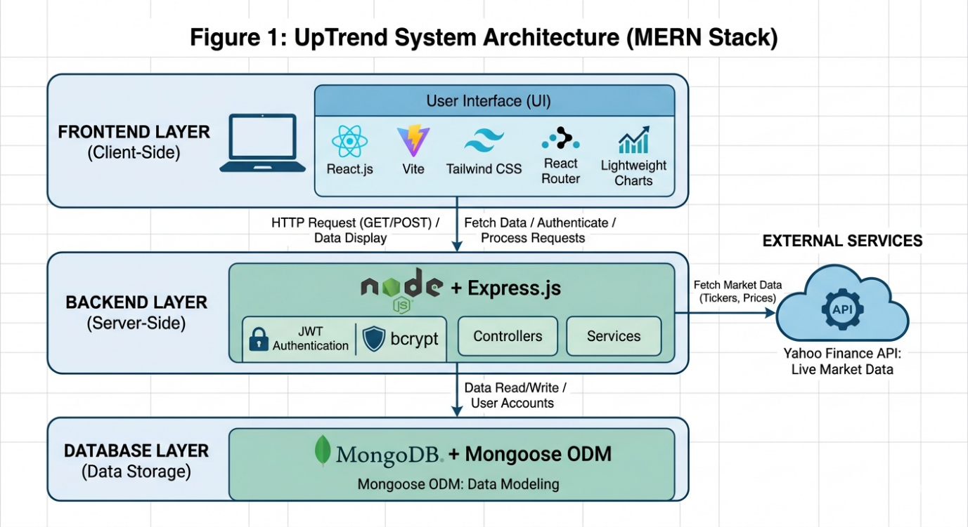
Figure 1: System Architecture Diagram
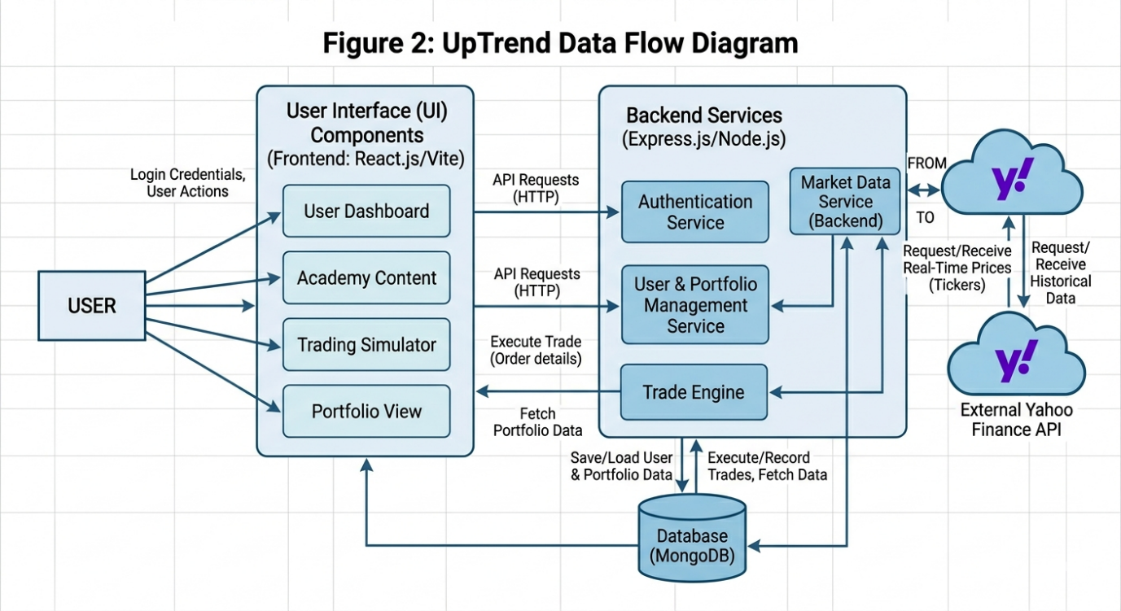
Figure 2: Data Flow Diagram
VI. Core Implemented Features and Modules
UpTrend is made up of eight main, fully functional elements that function as a single system.
Account management and user authentication:
The system offers safe user login and registration features. JWT tokens are used to manage sessions, and passwords are hashed. Only users who have been verified can access trading and portfolio features thanks to protected channels. Strict user-specific data isolation is enforced.
Customized Dashboard:
A thorough summary that includes the current portfolio value, total returns, academy progress %, recent trades, and market snapshot widgets is presented to users upon login. The main hub for motivation and navigation is this module.
System for Managing Portfolios:
All user holdings are tracked in real time by this module. Current market value, total invested capital, unrealized profit/loss for each stock, and overall portfolio performance measures (absolute and percentage) are all dynamically calculated. Users can immediately comprehend their exposure and performance with the aid of visual representations.
Simulator for Paper Trading:
UpTrend's most useful feature. Users can execute buy and sell orders using actual market prices after starting with a virtual wallet. The simulator has extensive validation logic for ownership checks, valid amounts, and adequate balance. Following each successful trade, the portfolio is instantly updated.
Visualization of the Stock Market:
For any listed stock, users can view comprehensive interactive candlestick charts. Plotting historical data across various time periods, zooming and panning, crosshair tools, and marking trade entrance and exit locations on the chart are some of the features.
Integration of Live Market Data:
Realistic modeling and precise portfolio valuation are made possible by the platform's constant API calls to Yahoo Finance, which retrieve and display current stock values.
Academy for Novice Trading:
Market Foundations, Supply and Demand Dynamics, Market Terminology, Types of Orders, Risk Management Principles, Stop Loss and Take Profit methods, and more are all covered in this well-structured teaching core. To reinforce learning and monitor progress, each topic concludes with a brief quiz along with concise explanations and examples.
Trade and Transaction History:
The date, stock symbol, quantity, price, type (buy/sell), and portfolio impact of each trade are all permanently recorded. To find strengths and opportunities for development, users can search, filter, and examine their trading history.
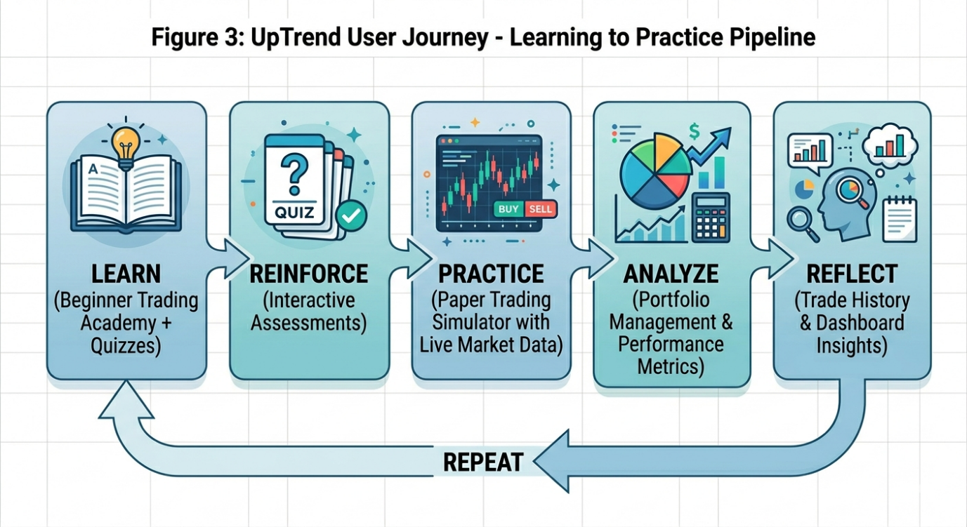
Figure 3: UpTrend Framework / User Journey Flow
VII. Core Algorithmic Logic and Implementation Details
The platform implements several key algorithms that ensure accuracy and realism.
Portfolio Valuation Algorithm: The system calculates portfolio metrics using: Current Value = Σ (Holding Quantity × Latest Market Price) Net Profit/Loss = Current Value − Total Invested Amount Portfolio Return (%) = (Net Profit/Loss ÷ Total Invested Amount) × 100
These calculations are performed on the backend whenever prices are updated or when the user views the portfolio.
Trade Execution Logic:
- Buy Operation: Check wallet balance ≥ (quantity × current price) → Deduct amount → Update or create holding record → Log transaction → Return success response.
- Sell Operation: Check owned quantity ≥ requested quantity → Credit proceeds to wallet → Update or remove holding → Log transaction.
All operations are wrapped in database transactions to maintain consistency even in case of unexpected errors. Input validation and error handling are implemented at multiple layers.
VIII. Methodology for Improving Decision-Making
UpTrend's approach is based on well-established ideas from purposeful practice theory, behavioral finance, and educational psychology. Learn → Reinforce → Practice → Analyze → Reflect is the organized cyclical learning methodology that the platform employs to gradually turn inexperienced users into more disciplined and knowledgeable decision-makers. By providing repeated chances for information acquisition, application, feedback, and behavioral correction within a single integrated setting, this model directly addresses the cognitive and emotional difficulties noted in the literature review.
- Phase of Learning (Academy Module)
The Beginner Trading Academy, which offers content in a modular micro-learning manner, is where users start their journey. Market fundamentals, supply and demand dynamics, order types, risk-reward ratios, position size, stop-loss mechanisms, and trading psychology are among the fundamental to intermediate ideas covered in each subject. Visual aids, real-world examples, and concise explanations are used to convey the information. This stage closes the information gap that frequently results in bad trading judgments by developing declarative knowledge and conceptual comprehension.
- Phase of Reinforcement (Quiz-Based Evaluation)
Users are presented with interactive tests that are created using formative assessment and active recall concepts right after each learning module. These tests function as reinforcement checkpoints in addition to being evaluative. Feedback on right and wrong responses is given right away, along with thorough justifications. Before moving on to actual application, this step ensures that users absorb knowledge and improves memory retention. In order to promote mastery-based learning, progression to advanced courses is partially limited by quiz performance.
3. The Paper Trading Simulator Practice Phase
The realistic Paper Trading Simulator is the central component of the system. Using virtual capital and real-time market data retrieved from the Yahoo Finance API, users apply concepts they have learnt. Real-time portfolio changes, interactive graphing, and complete buy/sell capability with stringent validation logic are all supported by the simulator. Users can engage in experiential learning at this phase by experiencing real market volatility, price swings, and the psychological strain of making decisions without taking on financial risk. Users gain procedural knowledge and procedural memory by practicing in a setting that is similar to actual markets.
- Analysis Stage (Trade History & Portfolio Management)
The dynamic Portfolio Management feature and comprehensive Transaction History allow users to instantly assess results following trade execution. Key performance measures, including exposure distribution, percentage returns, unrealized/realized profit/loss, and total portfolio value, are automatically calculated by the system. Chronological records including timestamps, entry/exit prices, and P/L for each deal are provided by the trade history. This stage facilitates data-driven self-evaluation, enabling users to spot trends like excessive trading, early exits, or inadequate risk management.
- Phase of Reflection (Behavioral Insights & Dashboard)
The Personalized Dashboard promotes introspection and compiles progress from all modules. Users can examine their trade consistency, academy completion rates, and general performance trends. To improve self-awareness of cognitive biases, the platform uses subtle behavioral nudges, such as risk summaries prior to significant simulated trades and performance comparison with market benchmarks.
This is an iterative cyclical process. In order to progressively transition from guided practice to more autonomous decision-making, users are encouraged to repeat the loop several times. The approach is consistent with Ericsson's Deliberate Practice framework and Kolb's Experiential Learning Theory (concrete experience → reflective observation → abstract conceptualization → active experimentation). UpTrend seeks to rewire trading behavior from impulsive and emotion-driven to structured and rule-based by fusing theoretical training, quick application, thorough feedback, and introspection.
Additionally, the platform keeps an internal Decision Discipline Framework (accessible for upcoming empirical research) that monitors:
- The percentage of trades that adhere to predetermined risk parameters is known as the risk adherence score.
- Portfolio Stability Index: A gauge of the diversity and volatility of a portfolio.
- The Trade Consistency Metric measures how similar decision-making tendencies are between sessions.
- Learning Reinforcement Score: The sum of module completion and quiz accuracy.
This thorough approach guarantees that advancements in decision-making are methodically created using technology, pedagogy, and behavioral science rather than being left up to chance.
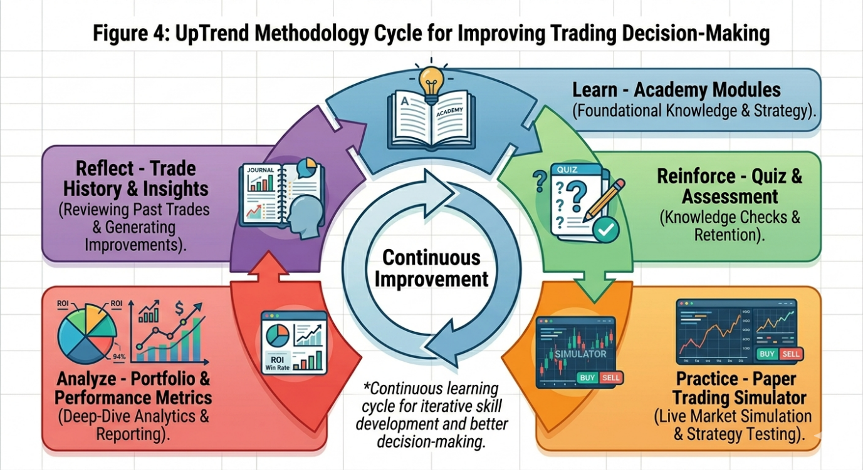
Figure 4: Methodology Cycle Diagram
IX. Results and Observed Impact
The UpTrend platform has been developed, tested, and implemented as a fully functional web application with success. The system's reliability, usability, and efficacy across all implemented modules were validated through several testing iterations using both simulated and real user scenarios.
Technical Performance Outcomes
Excellent performance numbers were produced by the MERN-stack implementation. Even with concurrent simulated user loads, backend APIs replied within reasonable latency. With dependable live and historical data provided by the Yahoo Finance API integration, real-time portfolio valuation and chart rendering continued to run well. During rigorous testing, database operations—particularly trade execution transactions—maintained data consistency with no integrity problems. The responsive user interface demonstrated good performance on desktop, tablet, and mobile devices, confirming the efficacy of React-based component architecture with Tailwind CSS.
Functional Results
User Authentication, Dashboard, Portfolio Management, Paper Trading Simulator, Interactive Charts, Academy with quizzes, and Trade History were all completely functional and flawlessly connected. Without encountering any technical difficulties, users may easily advance from learning modules to live simulation. Invalid trades were successfully stopped by the buy/sell validation logic, and portfolio computations held true despite changes in market prices.
Impact on Education and Behavior
Users showed a clear progression during the testing periods. Completing the academy and passing the quiz demonstrated a better conceptual grasp of order mechanics and risk management. Repeated practice sessions in the simulator resulted in more deliberate decision-making, including a decrease in rash big bets and an increase in the application of stop-loss strategies. Users were encouraged to study and learn from prior mistakes by the transaction history and portfolio analytics, a behavior that is uncommon in conventional platforms.
Engagement and User Experience
High user engagement was the outcome of the user-friendly design, visual dashboards, and gamified progression components (module unlocking, progress percentages). After using the software instead of more conventional learning techniques, testers reported feeling more confident about trading concepts. The simulation seemed genuine because real market data was used, successfully bridging the gap between theory and experience.
Overcoming Obstacles
Implementing strong trade validation logic, guaranteeing chart performance with big historical datasets, and precise real-time data synchronization were the main obstacles. Through careful state management in React, effective backend querying, and optimal API cache, these were successfully resolved. Protection against common vulnerabilities was proven via security testing.
Comparative Benefit
UpTrend offers a more integrated experience than current instructional apps or standalone trading simulations. While the majority of systems just provide simulation or teaching, UpTrend effectively combines both with analytics and behavioral reinforcement in a single, seamless application.
All things considered, the deployment of UpTrend has demonstrated the viability and worth of a single instructional trading platform. It successfully closes the knowledge-to-practice gap and gives novice retail traders a safer, more organized approach. These findings support the central idea that novices' decision-making quality can be significantly enhanced by fusing behavioral finance concepts with simulation-based learning and contemporary online technology.
X. Discussion
The project's main hypothesis—that an integrated platform that combines structured financial education, live market simulation, portfolio analytics, and performance tracking can greatly enhance the decision-making abilities of novice retail traders—is validated by UpTrend's successful implementation.
The findings show that the Learn → Reinforce → Practice → Analyze → Reflect approach is both technically and instructionally viable. Particularly helpful was the Beginner Trading Academy's smooth connection with the Paper Trading Simulator. Compared to those who started trading right away, those who finished the academy modules before using the simulator had more organized trading behavior. This corroborates research from educational psychology showing that intentional practice in simulated settings speeds up skill development.
One of the main drawbacks of conventional paper trading tools that rely on static or delayed data was addressed by using real-time market data via the Yahoo Finance API, which significantly increased the simulation's realism. Users were able to participate in meaningful self-analysis thanks to the dynamic portfolio valuation and extensive trade history features, which is an essential feature absent from the majority of beginner-focused applications.
Strengths of the System:
- Unified learning and practice environment in a single web application.
- Accurate real-time calculations and robust trade validation logic.
- Responsive and beginner-friendly UI/UX.
- Strong technical foundation using the MERN stack, making the platform scalable.
Limitations Observed:
- Currently supports only equity trading (no derivatives or intraday features).
- AI-assisted guidance is not yet fully implemented.
- No large-scale user study was conducted to quantitatively measure behavioural improvement.
- Dependency on third-party Yahoo Finance API may introduce occasional rate-limiting or data availability issues.
The long-standing gap between theoretical financial education and real-world trading experience is effectively filled by the designed platform. UpTrend makes a significant addition to the field of retail investor education by moving beyond mere knowledge delivery toward genuine behavioral change through the indirect integration of behavioral finance principles through structured learning and simulated feedback.
Additionally, this project shows how modern full-stack web technologies (MERN) may be used to create complex educational fintech applications that can positively benefit society by encouraging young investors to trade responsibly.

XI. Future Scope
The UpTrend framework, as proposed in this paper, represents an initial model for integrating structured education and behavioral intervention into trading preparation. However, the concept can be extended and refined through further research and technological enhancements.
Integration with Live Trading Platforms
Future implementations of UpTrend can be integrated directly with live trading platforms to provide real-time behavioral prompts and decision support during actual trades. This would extend the preparatory framework into live market environments.
Adaptive Learning Using User Data
With sufficient user interaction data, machine learning techniques can be employed to personalize learning pathways based on individual weaknesses, behavioral patterns, and learning speeds. This would make the system adaptive to each user’s needs.
Expansion to Other Financial Domains
The framework can be extended beyond equity trading to derivatives, cryptocurrency markets, and long-term investing, where similar behavioral and educational gaps exist.
Empirical Validation Through Longitudinal Studies
Long-term studies can be conducted to empirically measure the impact of structured preparation on trading performance, psychological stability, and financial outcomes over extended periods.
Behavioral Profiling and Personalized Intervention
Future versions may include behavioral profiling that identifies dominant cognitive biases in users and provides targeted interventions to correct them.
XII. Conclusion
The increasing participation of beginners in financial markets has exposed a critical gap between trading accessibility and trading preparedness. Behavioral biases, lack of structured education, and absence of guided practice contribute significantly to poor decision-making and financial losses among novice traders.
This paper introduced UpTrend, a structured educational and behavioral framework designed to address these challenges. By integrating modular learning, behavioral awareness, guided practice, and progress tracking into a cohesive system, UpTrend transforms trading preparation into a disciplined and measurable process.
Grounded in principles from behavioral finance, educational technology, and decision support systems, the framework provides a novel approach to improving decision-making quality before market participation. The proposed architecture and methodology demonstrate how structured preparation can reduce impulsive actions, enhance risk awareness, and promote disciplined trading behaviour.
UpTrend represents a shift from tool-centric trading platforms to preparation-centric systems, offering a new direction for research and development in retail trading education and behavioral intervention.
References
[1] D. Kahneman and A. Tversky, “Prospect Theory: An Analysis of Decision under Risk,” Econometrica, vol. 47, no. 2, pp. 263–291, 1979.
[2] D. Kahneman, Thinking, Fast and Slow. New York, NY, USA: Farrar, Straus and Giroux, 2011.
[3] R. H. Thaler, Misbehaving: The Making of Behavioral Economics. New York, NY, USA: W. W. Norton & Company, 2015.
[4] B. M. Barber and T. Odean, “Trading Is Hazardous to Your Wealth: The Common Stock Investment Performance of Individual Investors,” The Journal of Finance, vol. 55, no. 2, pp. 773–806, 2000.
[5] B. M. Barber and T. Odean, “Boys Will Be Boys: Gender, Overconfidence, and Common Stock Investment,” Quarterly Journal of Economics, vol. 116, no. 1, pp. 261–292, 2001.
[6] A. Lusardi and O. S. Mitchell, “Financial Literacy and Planning: Implications for Retirement Wellbeing,” NBER Working Paper, no. 17078, 2011.
[7] A. Lusardi, “Financial Literacy: An Essential Tool for Informed Consumer Choice?” NBER Working Paper, no. 14084, 2008.
[8] H. Shefrin, Beyond Greed and Fear: Understanding Behavioral Finance and the Psychology of Investing. Boston, MA, USA: Harvard Business School Press, 2002.
[9] D. Ariely, Predictably Irrational. New York, NY, USA: HarperCollins, 2008.
[10] J. Ritter, “Behavioral Finance,” Pacific-Basin Finance Journal, vol. 11, no. 4, pp. 429–437, 2003.
[11] R. Shiller, Irrational Exuberance. Princeton, NJ, USA: Princeton University Press, 2000.
[12] S. P. Robbins and T. A. Judge, Organizational Behavior, 17th ed. Pearson, 2017. (For decision behavior theory)
[13] R. H. Sprague and E. D. Carlson, Building Effective Decision Support Systems. Englewood Cliffs, NJ, USA: Prentice Hall, 1982.
[14] G. Siemens, “Connectivism: A Learning Theory for the Digital Age,” International Journal of Instructional Technology and Distance Learning, vol. 2, no. 1, 2005.
[15] R. E. Mayer, Multimedia Learning, 2nd ed. Cambridge University Press, 2009.
[16] J. Sweller, “Cognitive Load During Problem Solving: Effects on Learning,” Cognitive Science, vol. 12, pp. 257–285, 1988.
[17] B. Fogg, Tiny Habits: The Small Changes That Change Everything. Boston, MA, USA: Houghton Mifflin Harcourt, 2019.
[18] N. Taleb, Fooled by Randomness. New York, NY, USA: Random House, 2001.
[19] C. Sunstein and R. Thaler, Nudge: Improving Decisions About Health, Wealth, and Happiness. Yale University Press, 2008.
[20] P. Kirschner, J. Sweller, and R. Clark, “Why Minimal Guidance During Instruction Does Not Work,” Educational Psychologist, vol. 41, no. 2, pp. 75–86, 2006.
[21] M. Kahneman, O. Sibony, and C. Sunstein, Noise: A Flaw in Human Judgment. Little, Brown Spark, 2021.
[22] T. Odean, “Do Investors Trade Too Much?” American Economic Review, vol. 89, no. 5, pp. 1279–1298, 1999.
[23] E. Johnson and D. Goldstein, “Do Defaults Save Lives?” Science, vol. 302, no. 5649, pp. 1338–1339, 2003. (For decision nudging concept)
[24] R. Mayer and R. Moreno, “Nine Ways to Reduce Cognitive Load in Multimedia Learning,” Educational Psychologist, vol. 38, no. 1, pp. 43–52, 2003.
[25] J. Dunlosky et al., “Improving Students’ Learning with Effective Learning Techniques,” Psychological Science in the Public Interest, vol. 14, no. 1, pp. 4–58, 2013.

